The benefits of weight training for distance runners

From: http://runnersconnect.net/

I’ll deviate a bit from normal formatting by starting off with a summary of the benefits of weight lifting, outlined in a masterful 2003 review article by Alan Jung at the University of Alabama. Later, we’ll look at specific implementations of each type of weight training.
Jung starts by describing the three basic types of weight training: circuit workouts, traditional weight lifting, and explosive weight lifting. Circuit training involves short exercises at a high intensity with little or no rest between the various exercises. A circuit might consist of five or ten different exercises, each done once for a certain amount of time or number of repeats.
Traditional weight lifting is just what it sounds like: pumping iron in the gym with slow, controlled weight movements.
Explosive training involves very fast lifts, like the Olympic clean-and-jerk lift or a two-legged bound.
- Circuit training seems to benefit the cardiovascular system somewhat, at least in less-experienced athletes. Since there is little or no rest between exercises, your heart rate can jump to as high as 80% of its maximum. Studies among untrained individuals have also found improvements in time-to-exhaustion on a treadmill test and the lactate threshold. There is little evidence as to whether circuit training is beneficial for an experienced distance runner.
- Traditional weight lifting, on the other hand, has not shown any benefit to the cardiovascular system. Tests of maximal oxygen consumption, even in untrained individuals, do not change after several-week weight lifting programs. However, they don’t decrease either, which is good news for runners. Additionally, studies using distance athletes have found that traditional weight lifting can lead to improvements in running economy, time-to-exhaustion, and neuromuscular coordination (which has relevance to top speed and may explain the increase in running economy).
- Explosive training has been directly connected to improved race performance at 5km. Additionally, it too seems to benefit running economy and neuromuscular coordination. It’s likely that the training stimulus is stronger with explosive work, since exercises like alternate-leg bounding are more sport-specific than lunges or squats with weights.

Traditional weight training routine for runners
The research on traditional weight lifting comes from a 1997 study by Johnston et al.2 Six female distance runners underwent a 10-week strength program with weight sessions three times a week. Recovery between exercises was approximately two minutes.
At the conclusion of the study, cardiovascular markers like VO2 max had not changed, but the experimental group’s running economy jumped by 4% while the control group showed no improvement.
For most leg exercises, you’ll aim for 4-6 reps. The 4-6 rep range allows for maximum muscle overload and will recruit the most muscle fibers leading to increased strength. Because rep ranges are shorter, all your mental energy is set on doing just 4-6 repetitions and therefore psychological intensity is maximized allowing you to achieve better muscle overload. This means that you should not use forced reps for more than one rep, or even better, try not to do forced reps at all. Arm exercises are often better performed with lighter weights and higher reps. Because each set requires heavy weights with maximum intensity rest times should be 2-3 minutes.

Plyometric training for runners
Finally, the research from an explosive training study comes from a 1999 paper by Paavolainen et al. at the KIHU-Research Institute for Olympic Sports in Finland.3 In this study, ten endurance athletes trained for nine weeks, replacing about 30% of their normal running training with explosive strength training. A control group of eight athletes did almost no ancillary training.
At the conclusion of the study, the experimental group had dropped 3.1% off their 5k time and boosted their running economy by 8%.
Because of this explosive requirement, plyometrics are the last building-block of a successful strength training regimen and should only be implemented once a runner has developed a solid foundation. Furthermore, it is essential that you practice good form when performing these exercises.
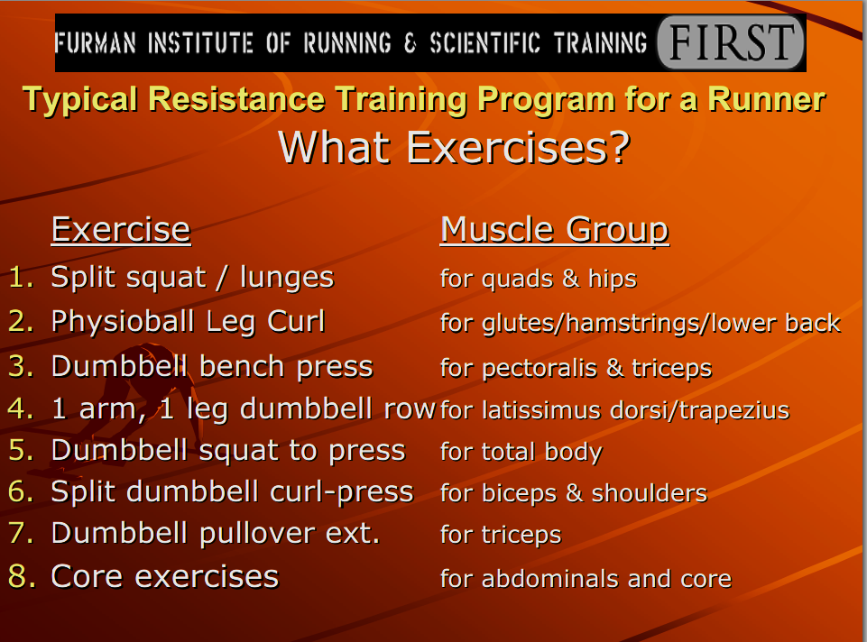
http://www2.furman.edu/sites/first/Documents/16_oct2324.pdf
